Project 18: Positioning

Objectives:

At the end of this project, you will be able to:
- Place elements on the page using relative and absolute positioning.
- Determine stacking order of elements on the page.
- Add a background gradient to a page.

Instructions:
- Create a new folder called "Positioning".
- Copy the skeleton file into this new folder and rename it to “index.html”.
- Create two new subfolders called “images” and “css”.
- Copy the seven image files for this project (provided by your teacher) into the “images” folder.
- Create a new, completely blank file in Notepad and save it to the “css” folder as "solitaire.css".
- Link the XHTML page to the CSS style sheet.
- Edit the XHTML and CSS files to create the following page:
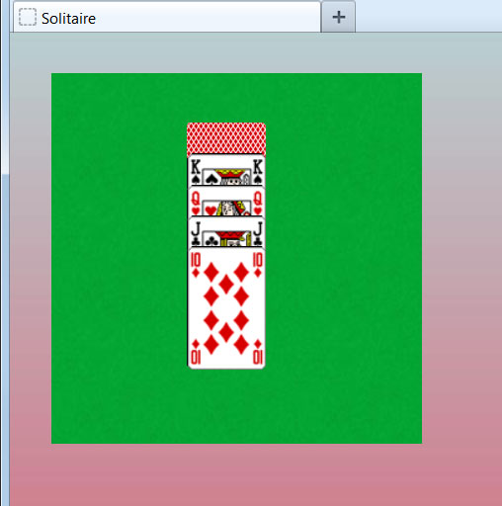

- Requirements:
  - The <div> that contains the green texture must use relative positioning instead of margins to move it down and to the right.
  - The five playing cards must be placed using absolute positioning.
  - Each of the playing cards must have a different z-index value to control the stacking order.
  - The page background gradient must be applied using a CSS class and must include the background-repeat property.

Rubric 18: Positioning

Name: ____________________________

Component | Possible Points | Score
The image files are located in the images folder and the CSS file is located in the css folder. | 2
The background gradient is applied to the <body> element via a CSS class. | 2
The background-repeat property is set for the gradient. | 2
A fallback background-color declaration is declared. | 1
The <div> for the green rectangle is set for relative positioning. | 2
The top and left properties have been set for the green <div> to create the distance from the top left corner of the page (margins aren’t used). | 2
The green texture shows on the <div> and a fallback color has been declared. | 2
The five playing cards have been placed using absolute positioning. | 3
Each of the five playing cards has a different z-index value assigned. | 2
The five cards show in the same stacking order as the example image. | 3
The five cards are in a similar location as in the example image. | 2
There are no XHTML or CSS errors. | 2
Total Score | 25

